Sample Syllabus
Teaching from Anatomy of the New Testament (7th ed.) with a Historical Framework
Prepared by C. Clifton Black

The seventh edition of Anatomy of the New Testament is a flexible textbook, adaptable for different organizations of an introductory course. For teachers in undergraduate public and private institutions, here is one way in which this textbook’s contents may be rearranged for a roughly chronological presentation of the New Testament.
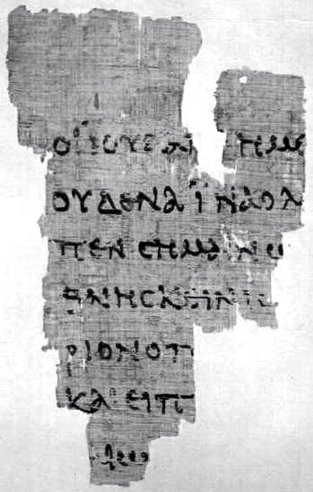
INTRODUCTION TO THE LITERATURE OF EARLIEST CHRISTIANITY

Course Goals

[Insert here the instructor’s own or whatever cant your institution’s accreditors require.]

Required Texts

• A modern translation of the Bible.

• Robert A. Spivey, D. Moody Smith, and C. Clifton Black, Anatomy of the New Testament (7th ed.; Minneapolis: Fortress Press, 2013).

Course Requirements

- Class attendance and participation
- Papers or quizzes
- Mid-term examination
- Final examination

Basis for Course Evaluation

Participation 20%
Papers or Quizzes 20 %
Mid-Term Examination 20%
Final Examination 40%

Course Schedule and Reading Assignments

Lectures | Readings
WEEK ONE  Introduction to the Course  _________________________________________________________  The World of the New Testament | Anatomy. xxxiv-xxxv, Timeline of the New Testament;  Prologue and Chapter 1:  “The World of the New Testament”
WEEK TWO  Jesus of Nazareth | Luke 7:1-50; 8:1-3; Matthew 5:1–48; 6:1-34; 7:1-29; Mark 11:1-33; 12:1-44; 13:1-37; 14:1-72; 15:1-47; 16:1-8  Anatomy, Chapter 6: “Jesus the Messiah”
WEEK THREE  The Spread of the Earliest Christian Mission | The Acts of the Apostles (entire)  Anatomy, Chapter 7: “Acts: Mission and Witness”
WEEK FOUR  Paul the Apostle (I) | 1 Thessalonians 4:13–5:1;  2 Thessalonians 2:1-17;  Galatians 1:6–2:21; 3:1-29  2 Corinthians 4:1-15; 10:1–13:10; Philippians 1:12-26; 2:1-11; Philemon 4-20  Anatomy, Chapter 8: “Paul: Apostle to the Gentiles”
WEEK FIVE  Paul the Apostle (II) | 1 Corinthians (entire);  Romans (entire)  Anatomy, Chapter 9: “1 Corinthians”; Chapter 10:  “Romans”
WEEK SIX  Paul’s Earliest Legacy:  Religious Communities in the Pauline Tradition  _________________________________________________________  Mid-Term Examination | Colossians 2:8-15; Ephesians 2:11-22; 1 Timothy 4:1-16  Anatomy, Chapter 11: “Deutero-Pauline Letters”
Semester Break
WEEK SEVEN  The Development of the Gospels  _________________________________________________________  The Gospel according to Mark | Mark (entire)  Anatomy, Chapter 2: “Mark: The Gospel of Suffering”
WEEK EIGHT  The Gospel according to Matthew | Matthew (entire)  Anatomy, Chapter 3: “Matthew: The Gospel of Obedience”
WEEK NINE  The Gospel according to Luke | Luke (entire)  Anatomy, Chapter 4: “Luke: The Gospel of Witnessing”
WEEK TEN  Other Letters to Young Christian Communities | James 2:14-26; 1 Peter 2:11-25; Hebrews 4:14–5:10; 2 Peter 3:1-13; Jude 3  Anatomy, Chapter 12: “The Catholic Epistles” (pp. 403-13, 420-24); Chapter 13: “Other Apostolic Writings” (pp. 425-37)
WEEK ELEVEN  The Gospel according to John | John (entire)  Anatomy, Chapter 5: “Luke: The Gospel of Jesus’ Glory”
WEEK TWELVE  The Johannine Tradition Evolves:  The Letters of John and the Book of Revelation | 1 John 4:1-21; 2 and 3 John;  Revelation 1:1-20  Anatomy, Chapter 12: “The Catholic Epistles” (pp. 414-20); Chapter 13: “Other Apostolic Writings” (pp. 438-53); “Epilogue” (pp. 455-60)
Final Examination

